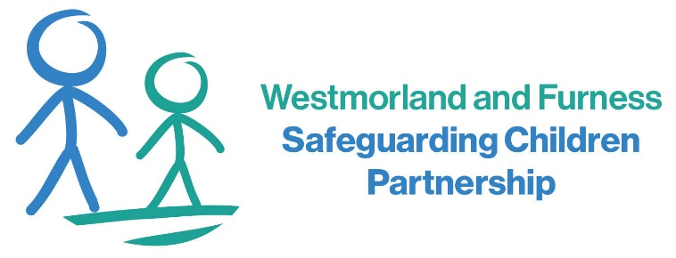
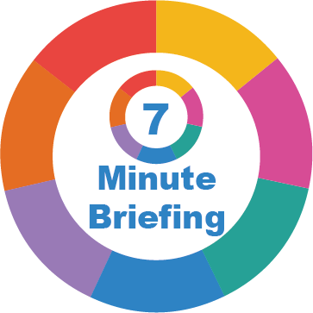
6. What Professionals Should Do
Professionals should be confident in identifying and responding to domestic abuse as a child safeguarding issue. If a child discloses abuse, listen carefully, remain calm and reassure them that they have done the right thing by speaking out. Ensure the child understands that the abuse is not their fault. Accurate recording of the child's voice verbatim is essential and concerns should be shared promptly in line with safeguarding procedures. Practitioners should adopt a Think Family approach whilst ensuring that the child's individual experiences are not lost within adult assessments. Consider the impact of the perpetrator's behaviour on all family members, complete risk assessments where appropriate, and make timely referrals to specialist domestic abuse services, or the Multi-Agency Children’s Hub (MACH). Effective information sharing between agencies is vital to safeguarding children and reducing future harm.

7. Questions for Practice
When working with a child or family, ask yourself: what is life like for this child at home? Have I spoken directly with the child and considered their lived experience? Am I focusing sufficiently on the perpetrator's behaviour and the risks created rather than solely on the protective actions of the non-abusing parent? Would I recognise the signs of coercive and controlling behaviour? Do I know how to access local domestic abuse services, family hubs and specialist support for children? Most importantly, am I viewing this child as a victim in their own right and taking action that improves their safety, recovery and long-term outcomes?

5. Impact on Development
Domestic abuse is recognised as an Adverse Childhood Experience (ACE) and can affect children throughout their lives. Exposure to chronic fear and stress activates the body's fight, flight or freeze response and can impact brain development, emotional regulation and cognitive functioning. Children may struggle to form secure attachments, develop healthy relationships or manage emotions effectively. Research links childhood exposure to domestic abuse with increased risks of anxiety, depression, self-harm, substance misuse, physical health problems and involvement in abusive relationships in later life. Abuse during pregnancy can also affect unborn babies through the impact of maternal stress and trauma. However, with timely support, protective relationships and effective intervention, children can heal, thrive and go on to have healthy relationships.

4. Recognising the Signs
Children impacted by domestic abuse may present in many different ways and may not always talk about their experiences. Some children become withdrawn, anxious, depressed or isolated from friends, whilst others display anger, aggression or challenging behaviour. Younger children may regress developmentally, experience bedwetting, separation anxiety or difficulties sleeping. Older children may engage in risk-taking behaviour, go missing, misuse substances or become involved in unhealthy relationships. Professionals may notice changes in attendance, concentration, behaviour, emotional regulation or engagement with services. Not all children will show obvious signs, and some may appear to be coping well despite experiencing significant harm at home. It is important to remain professionally curious and consider whether domestic abuse may be contributing to a child's presentation, particularly when concerns persist without an obvious explanation.

2. The Impact on Children
Domestic abuse can have a profound impact on children's emotional wellbeing, physical health, social development and educational attainment. Children living with abuse often describe feeling frightened, powerless, confused and responsible for what is happening within their family. They may alter their own behaviour in an attempt to prevent conflict or protect family members. National safeguarding reviews continue to identify domestic abuse as a recurring feature in serious incidents involving children. The Domestic Abuse Commissioner's 2025 report highlighted that whilst children are recognised in law as victims, many still struggle to access specialist support and their experiences can be overlooked within adult-focused interventions. Early recognition and intervention can significantly improve outcomes.

3. What Children Experience
The impact of domestic abuse extends far beyond witnessing arguments or violence. Children may hear threats, screaming, smashing of property or assaults occurring elsewhere in the home. They may witness injuries, police attendance, emergency responses or the fear experienced by a parent. Perpetrators may deliberately involve children by using them to pass messages, gather information or manipulate the non-abusing parent. Many children live with ongoing coercive control, where rules constantly change and family members adapt their behaviour to avoid conflict. Even after separation, children may continue to be harmed through contact arrangements, ongoing intimidation, stalking or manipulation of the non-abusing parent. Exposure to these experiences can undermine a child's sense of safety, stability and trust in the adults around them.

- Background
The Domestic Abuse Act 2021 recognised children as victims of domestic abuse in their own right for the first time. A child is defined as a victim if they see, hear, or experience the effects of domestic abuse and are related to either the victim or perpetrator. This legislative change reflects growing evidence that children are affected not only by witnessing incidents of abuse but also by living in an environment characterised by fear, coercion, control and intimidation. Children's experiences of domestic abuse must therefore be viewed as a safeguarding issue in their own right, rather than solely as part of an adult victim's experience.

Children as Victims of Domestic Abuse

5
7
6
4
3
2
1

