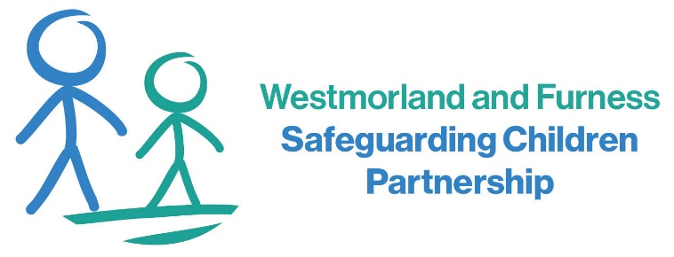

5. Ongoing Areas for Development
Despite the progress made, there remain several key areas requiring further development. The child’s lived experience is not yet consistently captured across all cases. This is particularly evident where children present as coping or where other competing needs, such as behavioural or educational concerns, take priority.
Recording quality continues to be variable. In some cases, this limits the clarity around identified risks, decision-making, actions taken, and outcomes achieved.
Domestic abuse can also become less visible within records when other factors are present, such as parental mental health, substance misuse, or neurodiversity. There is a need to ensure that domestic abuse remains a central focus, rather than being overshadowed or reframed solely through these additional vulnerabilities.
Family Help processes and documentation require further consistency. Planning is not always clearly recorded or easily accessible, which can limit oversight and continuity of support. We need to ensure that Family Help interventions are well documented and outcome-focused.

- Strengths in Current Practice
There were positive examples of timely referrals and effective front-door decision making, ensuring concerns are acted on quickly. Multi-agency working is well embedded, with coordinated input from education, health, police, and children’s services. Safety planning and risk management are evident, including appropriate use of MARAC in most cases. Education involvement, including Operation Encompass, continues to add value in safeguarding responses. Families are accessing a range of support services, including specialist domestic abuse provision, Family Hubs and wider family support.

7. Conclusion and Next Steps
Overall, the partnership has made measurable progress, particularly in recognising domestic abuse and strengthening multi-agency responses. However, improvements are not yet consistent across all areas, especially in relation to recording, lived experience, and risk analysis. The audit reinforces the importance of strong communication, professional challenge, and maintaining focus on children’s experiences. A new multi-agency action plan will be developed to address the identified areas for improvement. This will be overseen by the WFSCP Domestic Abuse Working Group to ensure continued progress and accountability.

6. Managing and Reviewing Risk
The audit identified challenges in sustaining a strong focus on risk over time. High-risk indicators and use of tools such as DASH and DARA are not always clearly recorded or carried through planning. Step-down processes can be inconsistent, with gaps in communication and reduced multi-agency involvement. Post-separation risk is not always revisited when circumstances change. There are also gaps in perpetrator engagement and addressing coercive control, including where behaviours are framed primarily as mental health issues.

- Evidence of Progress Since 2025
The re-audit found clear and measurable improvements across several areas since the previous audit in 2025. Domestic abuse is now more consistently identified, with practitioners more confident in explicitly naming it at an earlier stage. Encouragingly, children are increasingly being recognised and recorded as victims in their own right, rather than only in relation to adult experiences contrary to the recent JTAI thematic review on domestic abuse.
There is also strong evidence of a shift towards more trauma-informed practice. Language used within case recording is more consistently non-blaming, reflective, and sensitive to the lived realities of children and families. Professionals are better able to articulate the impact of domestic abuse on children’s emotional wellbeing and development.
In addition, the use of multi‑agency processes has become more embedded and proactive. Pathways such as MACH and MARAC are being used more consistently and effectively to support timely information sharing, coordinated safety planning, and collective risk management. This reflects improved partnership working and a more joined‑up system response to domestic abuse.

- Scope
The audit focused on six children aged 8 to 15, across South Lakeland, Barrow and Eden, where domestic abuse was a feature. A consistent audit tool was used, aligned with Children’s Services practice week audits and developed with the Domestic Abuse Working Group. A wide range of agencies contributed, including the local authority, police, health partners, and education. Findings were reviewed during a multi‑agency audit meeting in May 2026, encouraging shared reflection and professional challenge. The process also incorporated feedback from children and families to strengthen learning.
- Context
This briefing summarises findings from a follow‑up multi‑agency Domestic Abuse re‑audit conducted by the Westmorland and Furness Safeguarding Children Partnership. The re‑audit reviews progress since the original audit completed in May 2025 and evaluates the impact of actions taken. It forms part of the partnership’s wider commitment to quality assurance and continuous improvement. The focus was specifically on Family Help, recognising its crucial role in early identification and intervention. The aim was to understand what has improved, what remains unchanged, and where further action is needed.
Domestic Abuse Multi Agency Re-Audit Findings

5
7
6
4
3
2
1

