**Personal care**

|  |
| --- |
| I get help to brush my teeth, by My Mum, Dad, the person who looks after me.  1,639 Kids Brushing Teeth Illustrations &amp; Clip Art - iStock |
|  |
| My Mum/Dad or the person who looks after me, helps me get dressed.  See the source image |

|  |
| --- |
| I have a bath or shower. My Mum, Dad or the person who looks after me washes me. |
|  |
| My Mum/Dad or the person who looks after me wakes me up.  See the source image |

|  |
| --- |
| I have clothes and they fit me.  See the source image |
|  |
| My bed is washed and clean. |

|  |
| --- |
| My clothes are clean. |
|  |
| My bed is warm.  See the source image |

**Mealtimes**

|  |
| --- |
| There is food at home, and I eat breakfast.  See the source image |
|  |
| My Mum, Dad or the person who looks after me makes me breakfast and dinner.  See the source image |

|  |
| --- |
| See the source imageI have hot meals at home. |
|  |
| I have enough food on my plate, so I am not hungry.  See the source image |

**Love and affection**

|  |
| --- |
| My Mum, Dad, Carer loves me.  See the source image |
|  |
| My Mum, Dad, or the person who looks after me gives me kisses and cuddles, they say nice things to me.  See the source image |

|  |
| --- |
| My Brother and or Sister loves me.  See the source image |
|  |
| I see the people in my family who are important to me.  See the source image |

**Supervision**

|  |
| --- |
| I am always at home with a grown up. |
|  |
| People other than My Mum and Dad look after me.  See the source image |

|  |
| --- |
| I know the people who visit my house. |
|  |
| I look after my brother and or sister.  See the source image |

**School**

|  |
| --- |
| I am at School on time.  See the source image |
|  |
| I have friends at School.  See the source image |

|  |
| --- |
| I am happy at school.  See the source image |
|  |
| I have a packed lunch or school dinners. |

**After School**

|  |
| --- |
| I go to after school club or do activities I enjoy after school.  See the source image |
|  |
| I watch TV or play on a games console.  See the source image |

|  |
| --- |
| I play with toys and games at home with my family.  See the source image |
|  |
| I have help with my homework.  See the source image |

|  |
| --- |
| I watch YouTube.  See the source image |
|  |

|  |
| --- |
| My family are at home after School.  See the source image |
|  |

|  |
| --- |
| I go to bed the same time every night.  See the source image |
|  |
| My Mum, Dad or the person who looks after me puts me to bed.  See the source image |

My Mum, Dad, or the person who looks after me puts my pyjamas on.

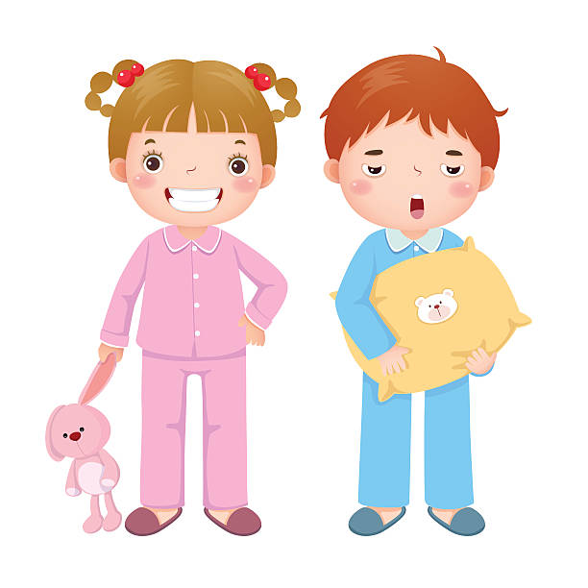

**Health**

|  |
| --- |
| I go to the Dentist.  See the source image |
|  |
| I have medicine if I am poorly.  See the source image |

|  |
| --- |
| I go to the Doctor if I feel unwell. |
|  |

**School holidays/weekends**

|  |
| --- |
| I have chores to do at home.  See the source image |
|  |
| I see my friends outside of School.  See the source image |

|  |
| --- |
| I go out with my family and do fun things on weekends and during holidays.  See the source image |
|  |