**Personal care**

|  |
| --- |
| I brush my teeth.  1,639 Kids Brushing Teeth Illustrations &amp; Clip Art - iStock |
|  |
| My Mum, Dad or the person who looks after me helps me wash and get dressed if I need help.  See the source image |

|  |
| --- |
| I have a bath or shower. |
|  |
| I get myself up in the morning using an alarm. |

|  |
| --- |
| I have enough clothes and they fit me. |
|  |
| My bed is washed and clean.  See the source image |

|  |
| --- |
| My clothes are clean.  See the source image |
|  |
| My bed is warm. |

|  |
| --- |
| I like the clothes I wear and feel good in them. |

**Mealtimes**

|  |
| --- |
| There is food at home, and I eat breakfast.  See the source image |
|  |
| My Mum, Dad, or the person who looks after me makes me breakfast and dinner.  See the source image |

|  |
| --- |
| See the source imageI have hot meals at home. |
|  |
| I have enough food on my plate, so I am not hungry.  See the source image |

|  |
| --- |
| I eat dinner with my famiSee the source imagely. |
|  |

**Love and affection**

|  |
| --- |
| My Mum, Dad, or the person who looks after me loves me.  See the source image |
|  |
| My Mum, Dad, or the person who looks after me gives me kisses and cuddles, they say nice things to me.  See the source image |

|  |
| --- |
| My Brother and or Sister loves me.  See the source image |
|  |
| I see the people in my family who are important to me.  See the source image |

**Supervision**

|  |
| --- |
| I am at home on my own. |
|  |
| See the source imagePeople other than My Mam and Dad look after me. |

|  |
| --- |
| I know the people who visit my house.  See the source image |
|  |
| I look after my brother and or sister.  See the source image |

|  |
| --- |
| I have to be home by a certain time.  See the source image |
|  |
| My Mum, Dad or the person who looks after me ask who I am going out with.  See the source image |

|  |
| --- |
| My Mum, Dad or the person who looks after me checks what I am doing online.  See the source image |
|  |
| My Mum, Dad or the person who looks after me gives me some independence.  See the source image |

**School**

|  |
| --- |
| I am at School on time. |
|  |
| I have friends at School.  See the source image |

|  |
| --- |
| I am happy at school. |
|  |
| I have a packed lunch or school dinners. |

|  |
| --- |
| I walk to school on my own. |
|  |
| There is someone at School I can talk to.  See the source image |

|  |
| --- |
| I take my brother and or sister to School. |
|  |

**After School**

|  |
| --- |
| I go to after school club or do activities I enjoy after school. |
|  |
| I watch TV or play on a games console. |

|  |
| --- |
| My family are at home after School |
|  |
| I have help with my homework if I need it. |

|  |
| --- |
| I have social media and or watch YouTube.  See the source image |
|  |

Mum, Dad or the person who looks after me asks me about my day and talks to me after school.

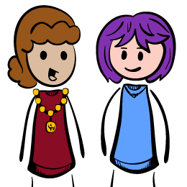

**Bedtime**

|  |
| --- |
| I go to bed the same time every nightSee the source image |
|  |
| Mum, Dad or the person who looks after me says goodnight. |

I decide when it is my bedtime.

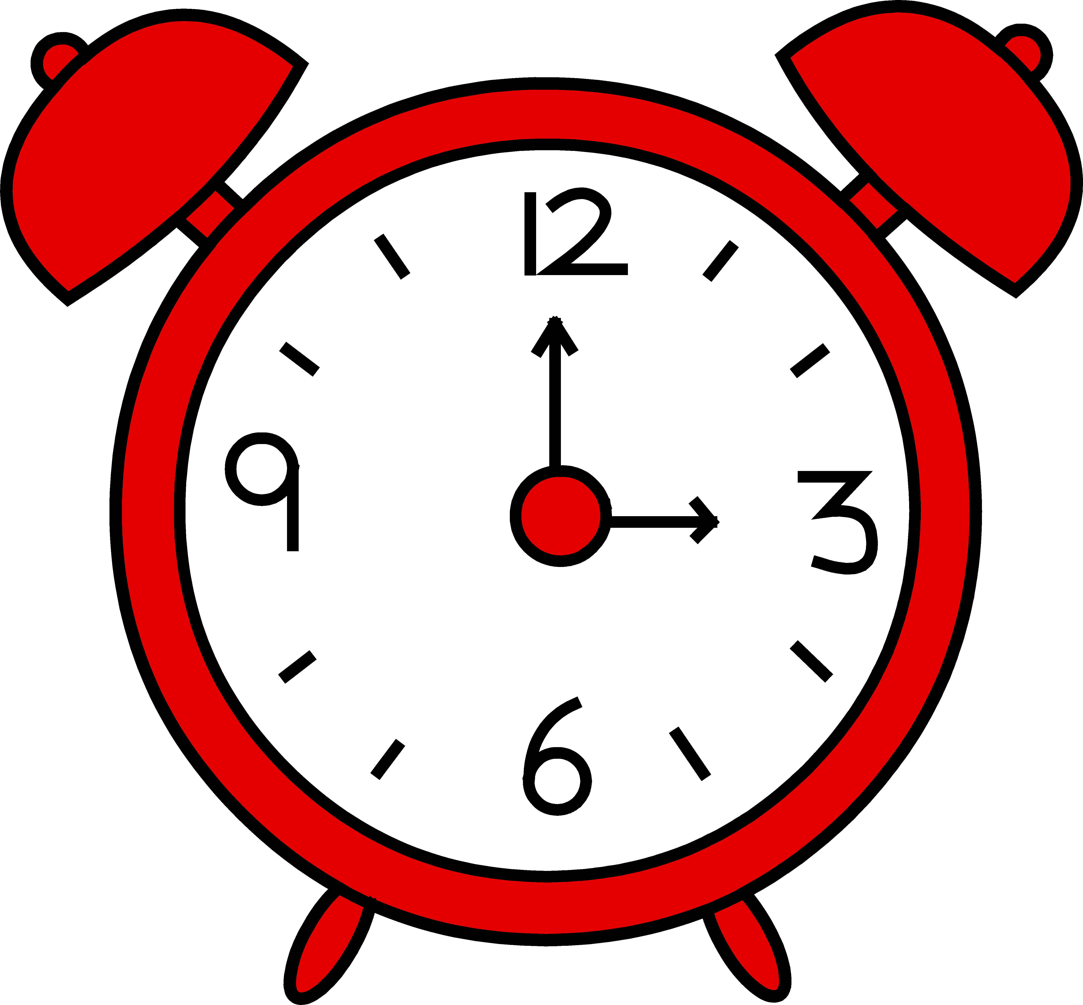

I get myself ready for bed.

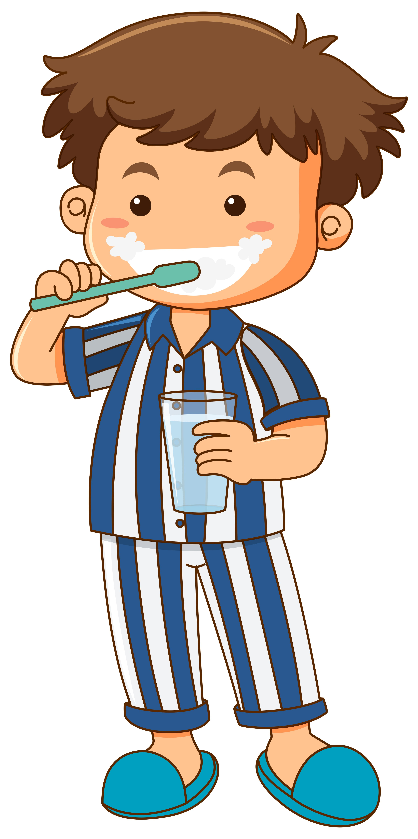

**Health**

|  |
| --- |
| I go to the Dentist.  See the source image |
|  |
| I have medicine if I am poorly.  See the source image |

|  |
| --- |
| I go to the Doctor if I feel unwell. |
| I don’t drink alcohol and take drugs.  See the source image |

**School holidays/weekends**

|  |
| --- |
| I have chores to do at home. |
|  |
| I go out with my friends. |

|  |
| --- |
| I go out with my family and do fun things on weekends and during holidays. |
| Mum, Dad, or the person who looks after me work at the weekend and in the holidays.  See the source image |